**Internal Job Moves through   
Talent Marketplace**

User Manual for Associates

Contents

**Completing your profile** 2

**Requesting a one-time confirmation from Home Manager** 4

**Applying for and managing job applications** 6

## **Completing your profile**

This is a critical step that will allow the Talent Marketplace to showcase the most relevant opportunities for you.

1. [Access Talent Marketplace](https://be.cognizant.com/sites/operations/global-talent-supply-chain/SitePage/540217/talent-market-place) by searching on Be.Cognizant or on OneCognizant. Talent Marketplace is our internal fulfilment platform designed for Associates to proactively search for internal job opportunities.
2. Open the Talent Marketplace application and select the role as ‘Associate’ to visit the iAspire home page.

Select Associate Role

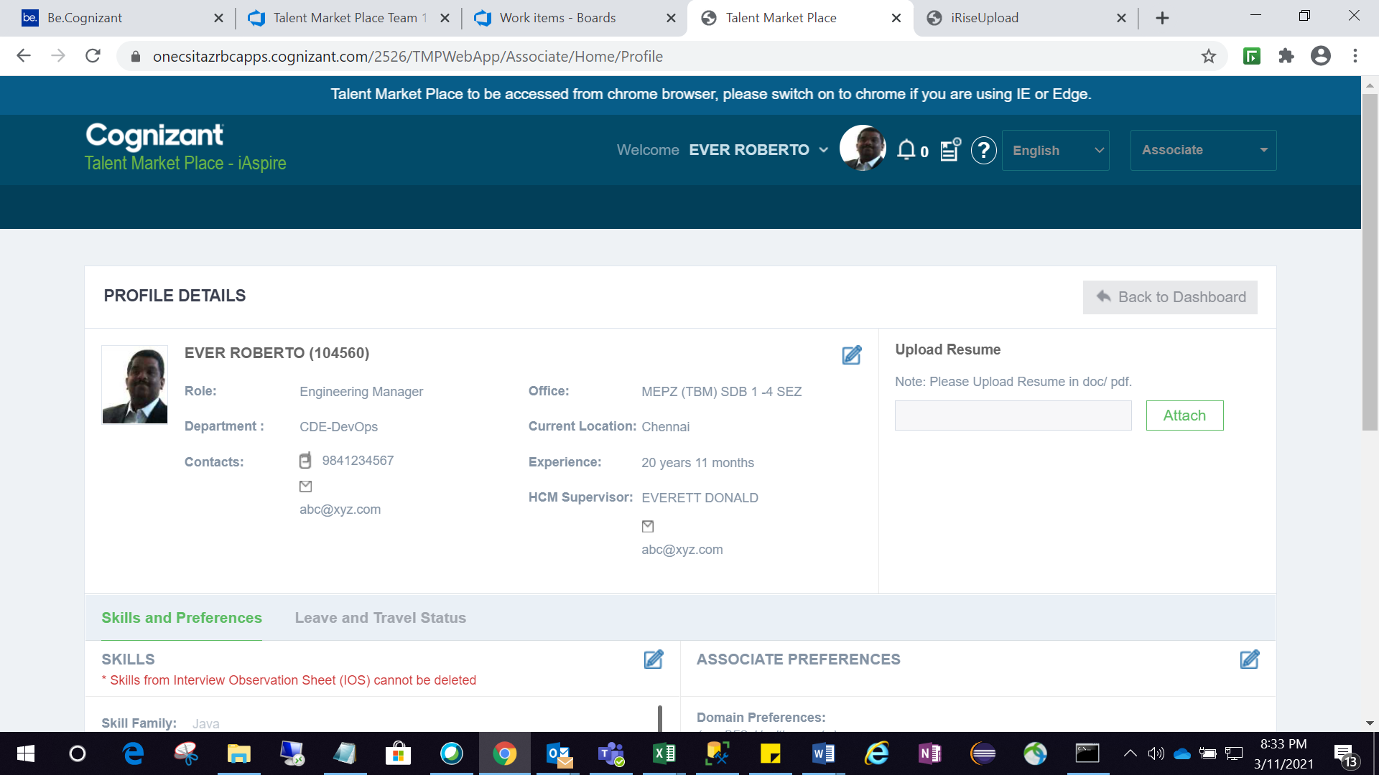

1. Update your skill profile 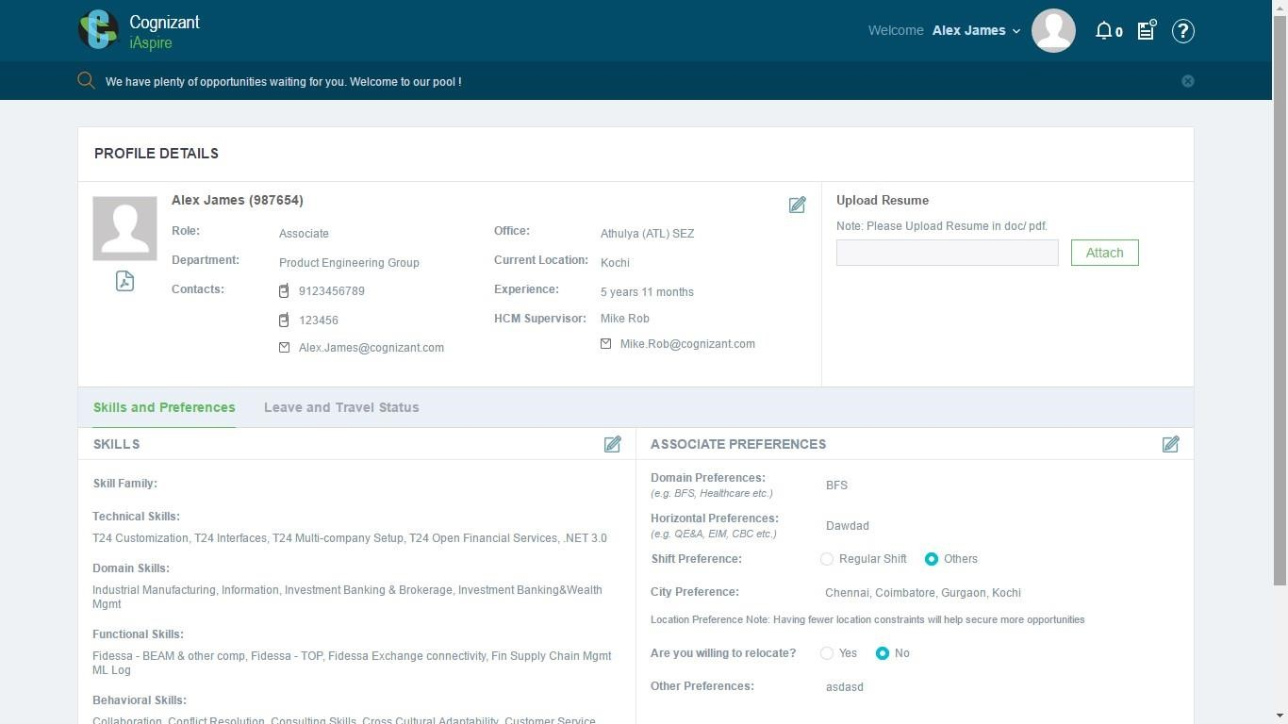

Click to edit your skills.

1. After updating skill profile, click on “Save” button

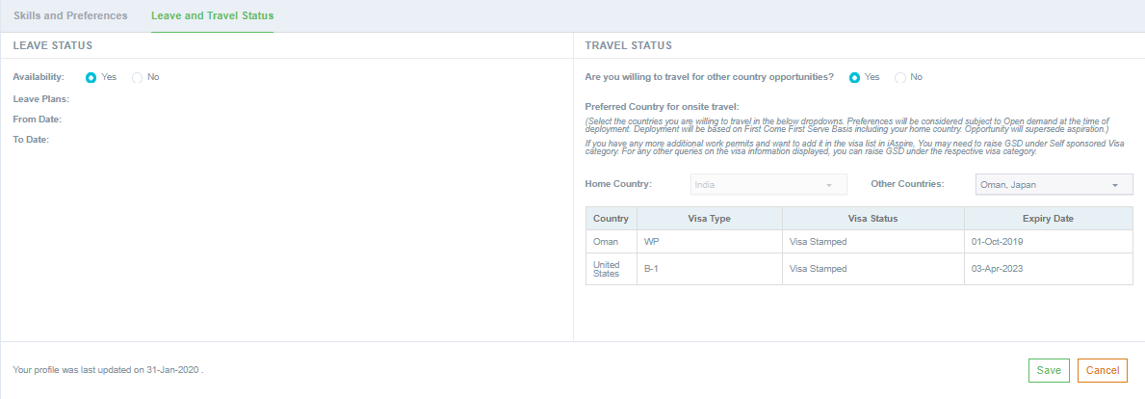

Click Save

1. Once the profile is saved, click on “Back to Dashboard” to finish the profile updation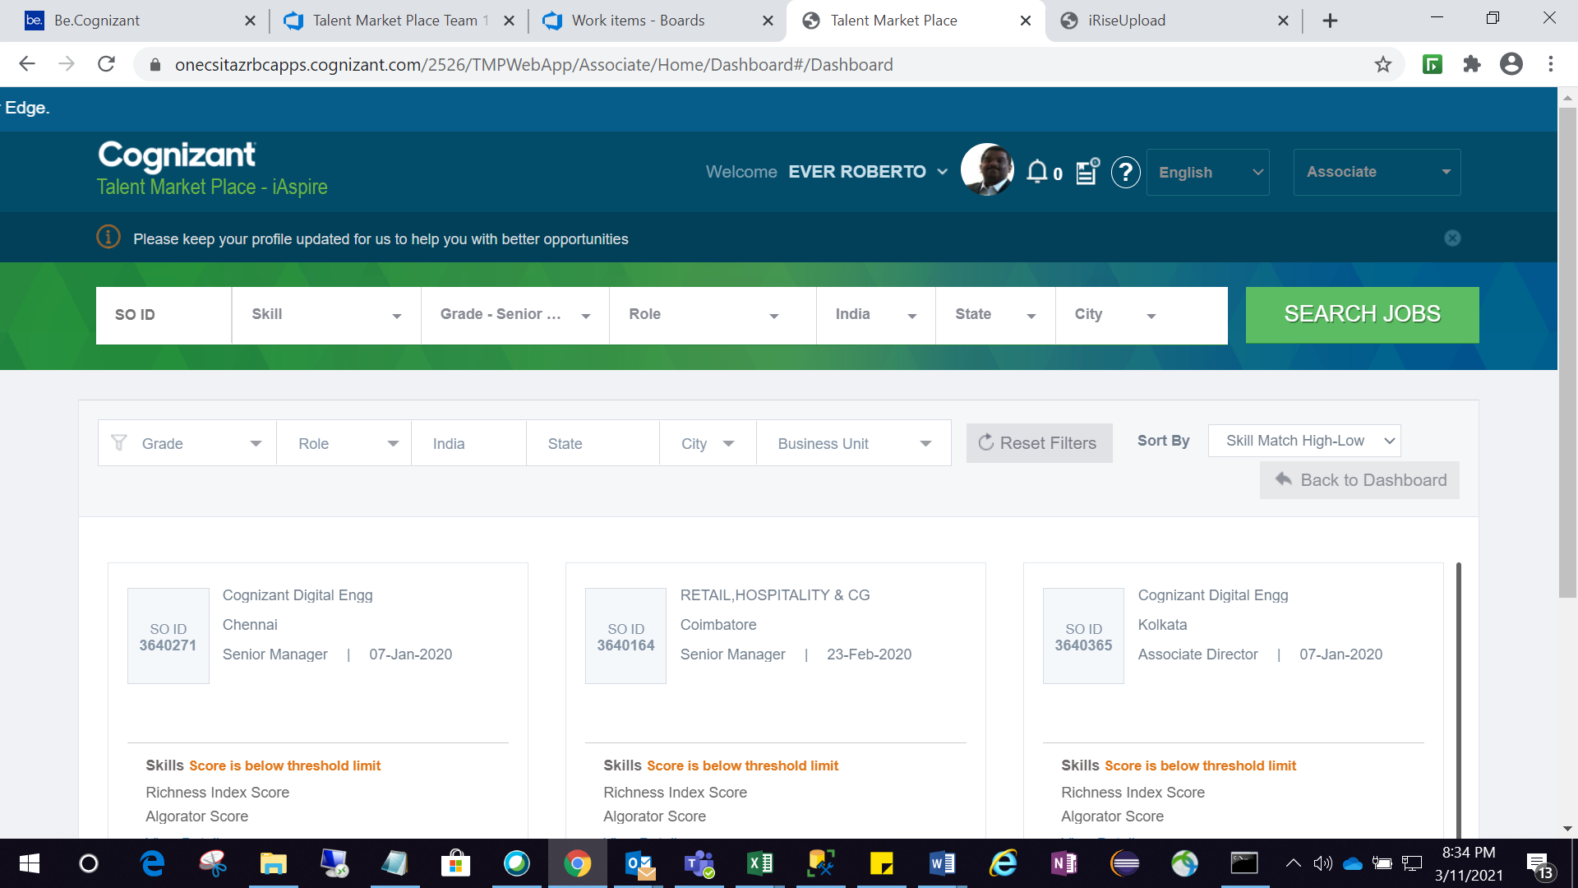

Click Back to Dashboard

1. Associates for whom the My Career App (MCA) is enabled will be redirected to MCA application to update their skills

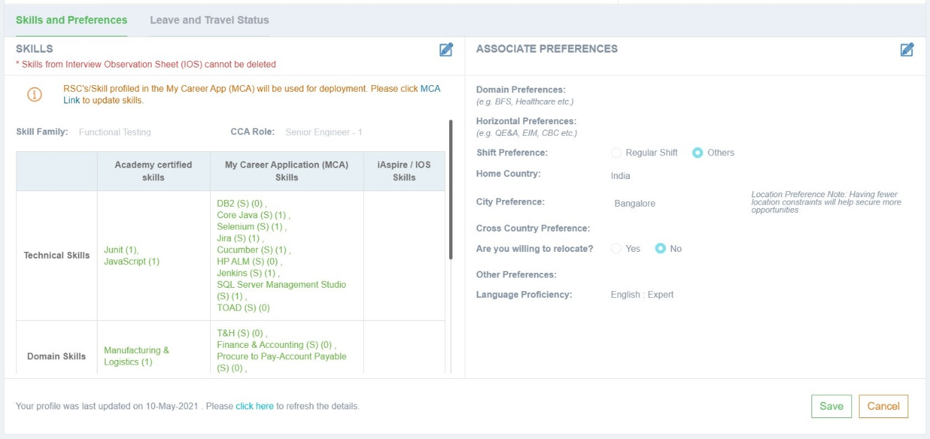

Click to visit MCA to update skills

1. It will take up to 24 hours for the updated skills in MCA to reflect in Talent Marketplace

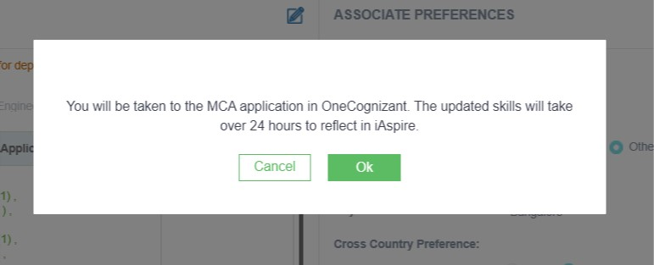

## **Requesting a one-time confirmation from Home Manager**

Associates need to receive a one-time blanket approval from their Home Manager to apply for open positions. Before you apply, discuss your career development aspirations and job move opportunities with your Manager and receive their consent ahead of the application

To raise a blanket approval request:

1. Click on the “Ability to Apply” button on the dashboard

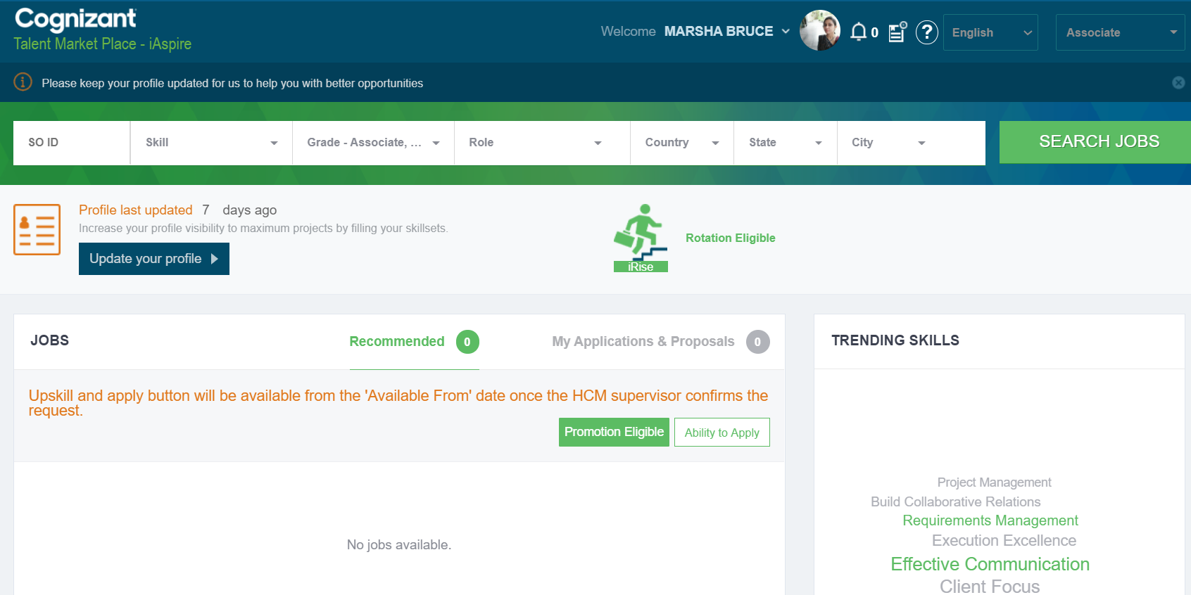

Click ‘Ability to Apply’ to initiate request to home manager/ supervisor

1. Enter the reason for raising the request and the date from which the you want to start applying for promotion eligible positions (it cannot be beyond 4 weeks from the current date)

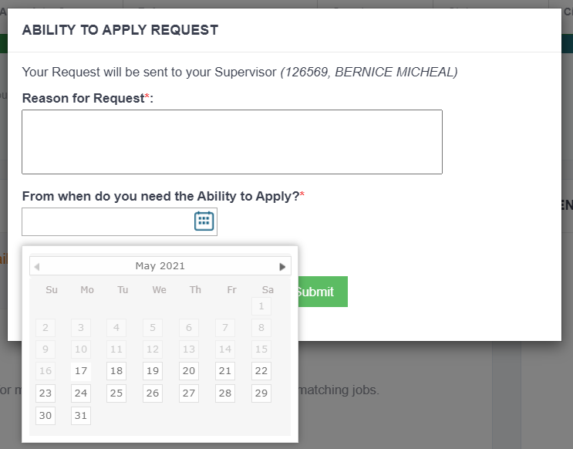

1. Once you submit the request, it will be notified to your Home Manager with a copy to the Project Manager (PM) and proxy PM. Your home manager will receive the approval request in Talent Marketplace (under iRise Requests) and have the option to ‘Confirm’ your request or ‘Defer’ it to a later date.

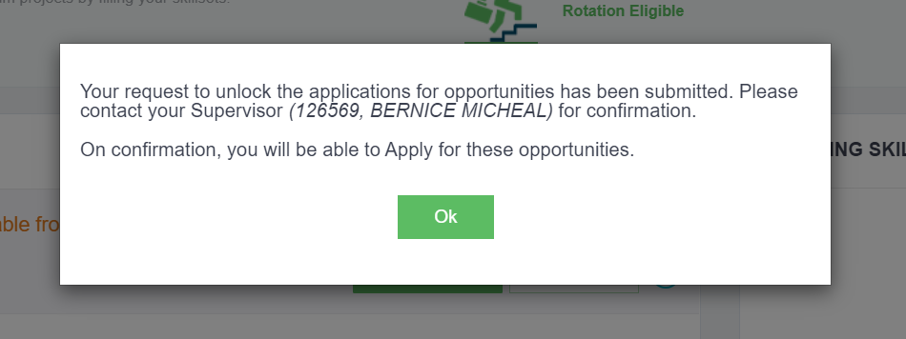

1. You can view the status of your request on your dashboard

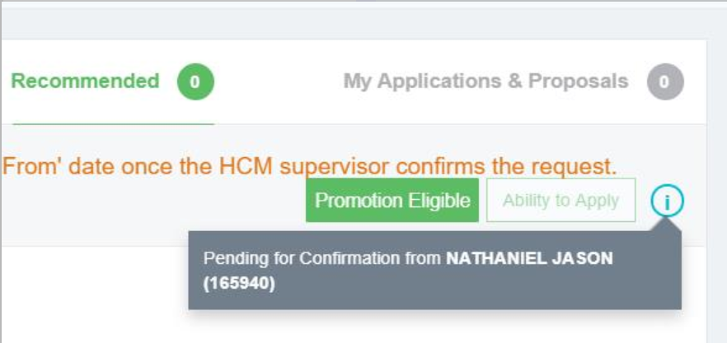

1. Once you receive confirmation from your Home Manager, you will be able to apply for opportunities.



## **Applying for and managing job applications**

In pilot phase of the Talent Marketplace rollout, eligible associates may apply for jobs that are flagged as “Promotion Eligible” and at the next level. At this stage, applications for any other jobs will be rejected.

1. To view only the Promotion Eligible jobs, select the ‘Promotion Eligible’ filter in your dashboard.

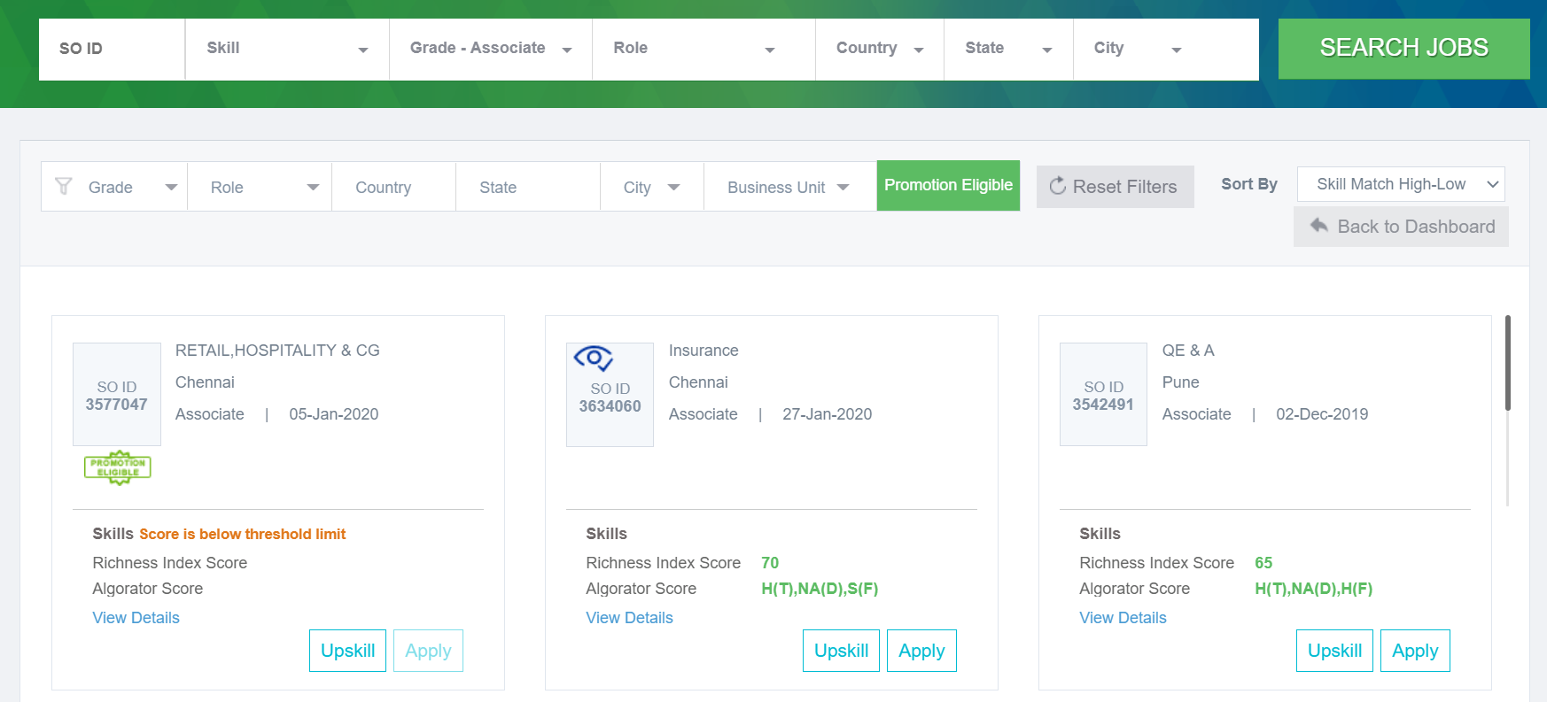

Click to filter Promotion Eligible jobs

1. After the filter is activated in dashboard – you will view only Promotion Eligible SOs

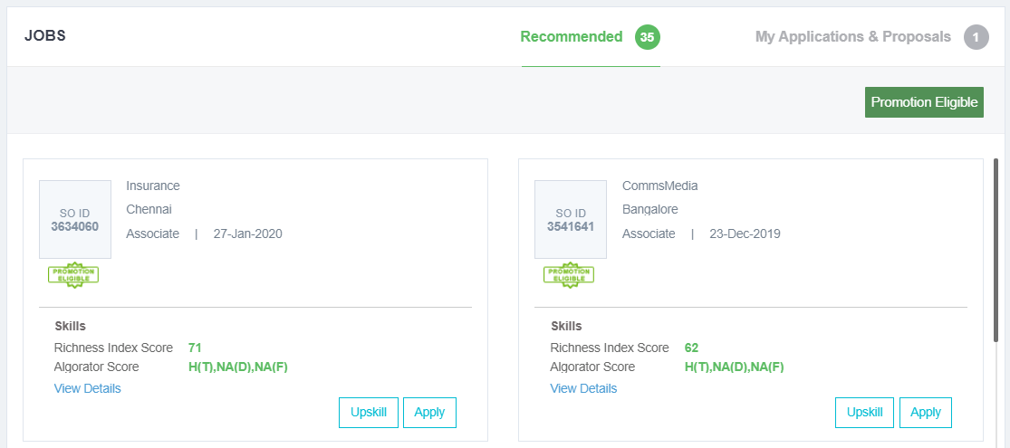

1. You can apply for a promotion eligible position only if your skillsets are greater than a 40% match (Richness Index - which uses both technical skills and domain skills to calculate the match score).*

*\*Associates in Germany and France can apply for opportunities irrespective of the 40% match score.*



1. Upon application, the respective proposal will be moved under ‘My Applications and Proposal’ with the status as ‘Initiated for Proposal’.

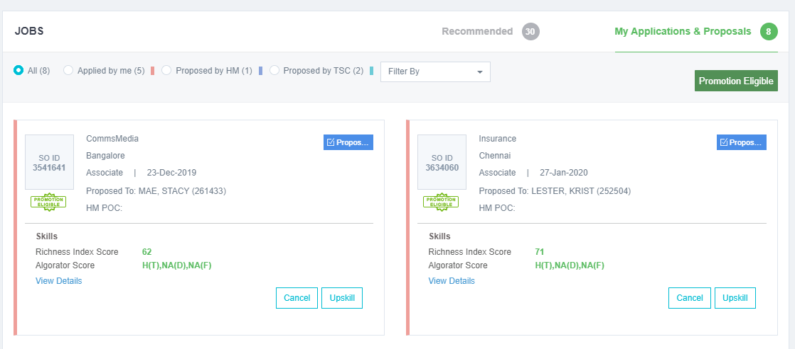

NOTE: At any point in time, an associate can apply for a maximum of 5 eligible jobs. In case of rejections, you can apply for additional eligible positions to have the total proposals at a maximum of 5.